**Topic: Recurrent Neural Network (RNN)**

**Instructions**

Please share your answers filled inline in the word document. Submit Python code and R code files wherever applicable.

Please ensure you update all the details:

**Name: Upadhyay Sachin Naresh**

**Batch Id: data science_08032021**

**Topic: Recurrent Neural Network.**

1. **Business Problem**
   1. **Objective**
   2. **Constraints (if any)**
2. **Work on each feature of the dataset to create a data dictionary as displayed in the below image:**

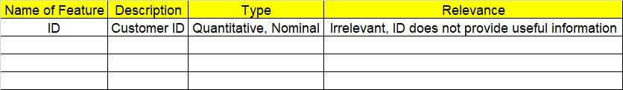

**2.1 Make a table as shown above and provide information about the features such as its Data type and its relevance to the model building, if not relevant provide reasons and provide description of the feature.**

**Using Python code perform:**

1. **Data Pre-processing**

**3.1 Data Cleaning, Feature Engineering, etc.**

**3.2 Outlier Imputation if applicable**

1. **Model Building**
   1. **Build the Recurrent Neural Network**
   2. **Train and Test the data**
   3. **Briefly explain the model output in the documentation**
2. **Share the benefits/impact of the solution - how or in what way the business (client) gets benefit from the solution provided**
3. **Use Tensorflow for this assignment depending on your system configuration either Tensorflowgpu or Tensorflowcpu version.**

# Note:

**The assignment should be submitted in the following format:**

* **Python code**
* **Code Modularization should be maintained**
* **Documentation of the model building (elaborating on steps mentioned above)**

**Problem Statement:-**

1. Here is the time series data [110,125,133,146,158,172,187,196,210].

Build RNN/LSTM model to predict the next 10 digits.

**Business Objective:** Maximize the accuracy of the model and recognize a data’s

sequential characteristics

**Business Constraint:** Minimize the Errors

2. Write down the multiple applications of RNN.

**ANSWER:**

* [Machine Translation](https://en.wikipedia.org/wiki/Machine_Translation)
* [Robot control](https://en.wikipedia.org/wiki/Robot_control)
* [Time series prediction](https://en.wikipedia.org/wiki/Time_series_prediction)
* [Speech recognition](https://en.wikipedia.org/wiki/Speech_recognition)
* [Speech synthesis](https://en.wikipedia.org/wiki/Speech_synthesis)
* Time series anomaly detection
* Rhythm learning
* Music composition
* Grammar learning
* [Handwriting recognition](https://en.wikipedia.org/wiki/Handwriting_recognition)
* Human action recognition[[](https://en.wikipedia.org/wiki/Recurrent_neural_network#cite_note-105)
* Protein Homology Detection
* Predicting subcellular localization of proteins
* Several prediction tasks in the area of business process management
* Prediction in medical care pathways

3. How to do select the inputs for a LSTM/RNN models. Explain in the terms of timesteps, samples and feature.

**ANSWER:**

The LSTM input layer is specified by the “input shape” argument on the first hidden layer of the network.

For example, below is an example of a network with one hidden LSTM layer and one Dense output layer.

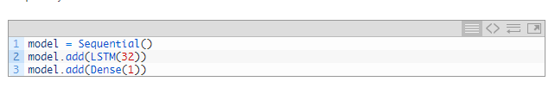

In this example, the LSTM () layer must specify the shape of the input.

The input to every LSTM layer must be three-dimensional.

Samples - This is the len(dataX), or the amount of data points you have.

Time steps - This is equivalent to the amount of time steps you run your recurrent neural network. If you want your network to have memory of 60 characters, this number should be 60.

Features - this is the amount of features in every time step. If you are processing pictures, this is the amount of pixels. In this case you seem to have 1 feature per time step.

The input to every LSTM layer must be three-dimensional

Samples. One sequence is one sample. A batch is comprised of one or more samples.

Time Steps. One time step is one point of observation in the sample.

Features. One feature is one observation at a time step.

When defining the input layer of your LSTM network, the network assumes you have 1 or more samples and requires that you specify the number of time steps and the number of features. You can do this by specifying a tuple to the “*input shape*” argument.

For example, the model below defines an input layer that expects 1 or more samples, 50-time steps, and 2 features.

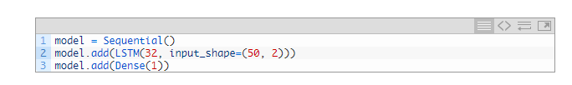

4. What are the disadvantages of MLP when dealing with sequence data.

**ANSWER:**

**Disadvantages of MLP:**

The use of feedforward neural networks on sequence data raises two majors problems:

Input & outputs can have different lengths in different examples.

MLPs do not share features learned across different positions of the data sample.

It include too many parameters because it is fully connected. Parameter number = width x depth x height.

Each node is connected to another in a very dense web — resulting in redundancy and inefficiency.

Gradient exploding and vanishing problems.

Training an RNN is a completely tough task.

It cannot system very lengthy sequences if the usage of Tanh or Relu as an activation feature.